Community Revitalization Strategy
Amenities and Assets Map Template
Legend
Defined CRSA
Subject property(ies)
Existing affordable housing other than subject property (LIHTC, Section 8, etc.)
Planned affordable housing other than subject property (identified in plans, under construction)
Banking and financial institutions
Recreational amenities (community parks, trails, gardens)
Civic and governmental institutions (City Hall, community centers, senior centers)
Childcare facilities
Educational amenities (public K-12, community college, adult/vocational
Food access amenities (grocery stores, farmers markets, community food pantries)
Healthcare and social service facilities (clinics, urgent care centers, hospitals)
Transportation amenities (bus or train stations, carpool parking, bikes lanes)
Retail amenities (local shopping, restaurants, nightlife)
Planned improvements (new bike lanes, sidewalk improvements, public lighting installation)
PID_12345

The CRSA Amenities and Assets Map Template helps create a map locating the subject property(ies) within the designated Community Revitalization Strategy Area, amenities, institutions, and assets, as well as where affordable housing is both currently located and planned. This template is a supplemental tool but the use of this template is not required to meet the threshold.

Template Instructions:
1

- Insert map image into black box.
1
- Use the dashed line to draw the boundaries of the CRSA.
- Use the shaded box to locate the subject property(ies).
1
- Identify the CRSA’s amenities, institutions, assets, and affordable housing developments by placing the corresponding icon onto the map.
1
  - Copy the icon from the legend
1
  - Paste it onto the correct location on the map
  - If there is more than one amenity, asset, or institution in a category, copy and paste another icon then click inside the icon to change the number
1
- Complete the Amenities and Assets Table.
1
  - Add rows to reflect additional amenities, institutions, assets in each category
  - Make sure the table row and category match the corresponding legend number
1
1
1
CRSA Amenities and Assets Map
PID_

CRSA Amenities and Assets Table
PID_

Complete the CRSA Amenities and Assets Table by filling in the name of each amenity located on the map. Applicants may add rows if there are more than two amenities in a category. If the CRSA has no amenities in a category, leave the row(s) blank.

Legend Number | Name of amenity, asset, or institution
Banking and financial institutions
1
2
Recreational amenities
1
2
Civic and governmental institutions
1
2
Childcare facilities
1
2
Educational amenities
1
2
Food access amenities
1
2
Healthcare and social service facilities
1
2
Transportation amenities
1
2
Retail amenities
1
2
Planned improvements
1
2
3

City of SAMPLE Community Revitalization Strategy
Amenities and Assets Map_SAMPLE Map and Table
PID_12345
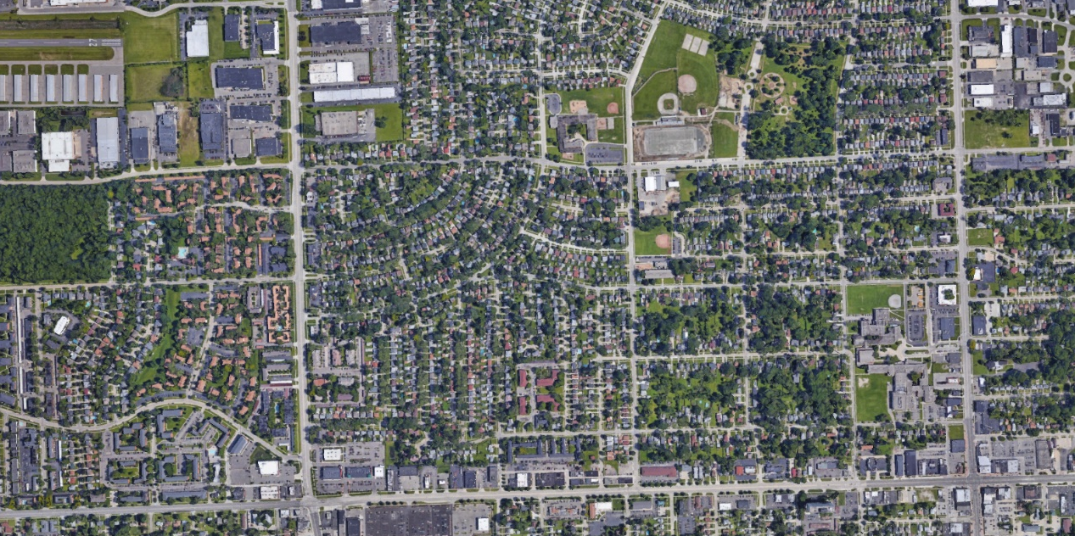

1

2
1
1
1
1
3
2
1
2
1
1
2
1

2
2

CRSA Amenities and Assets Table
PID_

Complete the CRSA Amenities and Assets Table by filling in the name of each amenity located on the map. Applicants may add rows if there are more than two amenities in a category. If the CRSA has no amenities in a category, leave the row(s) blank.

Legend Number | Name of amenity, asset, or institution
Banking and financial institutions
1 | Sample City Bank
Recreational amenities
1 | Sample Community Park
2 | Fido Dog Park
Civic and governmental institutions
1 | Community Center
2 | Sample City Hall
Childcare facilities
1 | N/A
2 | N/A
Educational amenities
1 | Sample High School
Food access amenities
1 | Aldi
2 | Sample City Community Food Pantry
Healthcare and social service facilities
1 | Community Urgent Care
Transportation amenities
1 | Main Street Bus Stop – Route 123
2 | South Street Bus Stop – Route 456
Retail amenities
1 | Downtown Sample City Shopping – Sue’s Gift Shop, Dan’s Clothing
2 | Downtown Sample City Restaurants – Sample Grill, Main Street Café
Planned improvements
1 | Park Avenue street light replacement project
2 | New bike route and sidewalk improvements
3 | Installation of public art, location of new Saturday art market

