Date: July 31, 2015

To: HOME Consortia (Lead and Participating Local Governments)
Interested Parties

From: Bill Pluta, Director
Office of Housing Coordination Services

CC: Mary R. Kenney, Executive Director, IHDA
Jerry Deese, HUD Representative, CPD, HUD

Re: HOME Consortium – State Certification

Per HUD’s most recent HOME Consortia Notice (CPD-13-002) dated April 9, 2013, the following current Participating Jurisdiction(s) under the HOME Program must submit their Consortium Agreements to HUD’s State Office in Chicago prior to June 30, 2015 (unless otherwise extended by HUD, or their current agreement includes a clause for automatic renewal):

-Urbana (current agreement does contain automatic renewal clause)

Current participating local governments (through FFY 2015) of each consortium are indicated on the attached list (Attachment A). Notices of Intent to apply for HOME funds as a proposed consortium, for an existing consortium that is adding members, or for a consortium that must sign a new HOME consortium agreement, were due to HUD March 1, 2015. Provided that subsequent deadlines can be met, the HUD Field Office may accept notification at a later date.

To paraphrase HUD’s CPD Notice, an existing consortium must execute a new HOME consortium agreement and provide the required qualification documents (prior to the above- referenced June 30, 2015 date), which must include the following:

- A written certification by the State that the consortium will direct its activities to the alleviation of housing problems within the State. (See Attachment B.) Note: The State certification may be signed by whoever has the authority to make the certification; it may be the Governor or his/her designee. If a designee signs, the signature line must indicate it is an “Authorized Official.” In Illinois, the Executive Director of the Illinois Housing Development Authority in fact has that designated authority. (See Attachment C.)

- One legally binding consortium cooperation agreement that has been executed by all consortium members:

  - Agreeing to cooperate to undertake or to assist in undertaking housing assistance activities for the HOME Program;

  - Authorizing one member unit of general local government to act in a representative capacity for all member units of general local government for the purposes of the HOME Program (i.e., the “lead entity”);

  - Providing that the representative member (also referred to as the lead entity) assumes overall responsibility for ensuring that the consortium’s HOME Program is carried out in compliance with the requirements of the HOME Program, including requirements concerning a Consolidated Plan in accordance with HUD regulations in 24 CFR Parts 92 and 91, respectively, and the requirements of 24 CFR 92.350 (a)(5); Note: The agreement must not contain a provision for veto or other restriction that would allow any member unit of local government to obstruct the implementation of the consortium’s approved Consolidated Plan.

  - Containing a provision requiring each member unit of local government to affirmatively further fair housing;

  - Specifying the three-year (qualification) period for which the Consortium is qualified to receive HOME funds, the time for which the agreement remains in effect, and the prohibition on withdrawal from the agreement during such time; Note: For an agreement executed in FY 2015, the qualification period is FY 2016-2018. The agreement must remain in effect until the HOME funds from each of the Federal Fiscal Years of the qualification period are expended.

  - Stating the program year start date for the consortium and that all units of general local government that are members of the consortium are on the same program year for CDBG, HOME, ESG, and HOPWA; and

  - Authorizing the lead entity to amend the consortium agreement on behalf of the entire consortium to add new members to the consortium. Note: This provision need not be in the agreement if the consortium members prefer to have all the members sign and approve additions.

  - Signed by the chief executive officer or authorized official of each member unit of local government. Note: If an urban county is part of the consortium, only the county (not all the members of the urban county) signs the consortium agreement. However, any unit of local government that is located in but is not participating as part of the urban county, and that wishes to be included in the HOME consortium, must sign the cooperation agreement. Also, for new consortia and renewal of existing consortia which include a non-urban county, the county cannot on its own include the whole county in the consortium. Any unit of local government in the non-urban county that wishes to participate as a member of the consortium must sign the HOME consortium agreement.

  - Accompanied by authorizing resolutions from the governing body of each member unit of local government, or other acceptable evidence that the chief executive officer is authorized to sign the agreement;

  - Containing, or accompanied by, a legal opinion from the lead entity’s counsel citing applicable law and concluding that the terms and provisions of the agreement are fully authorized under State and local law and that the agreement provides full legal authority for the consortium to undertake or assist in undertaking housing assistance activities for the HOME Program;

  - (Optional) Providing for an automatic renewal of the agreement in successive three-year qualification periods that also states that, by the date specified in HUD’s consortia designation notices or listed on HOME’s Consortia web page, the lead entity will have notified each participating unit of local government in writing of its right not to participate in the next three-year qualification period.

  - Stating that, for Consortia agreements with an Automatic Renewal Provision, copies of the aforementioned notification sent to each jurisdiction (k) must be sent to the HUD field office by the date specified in the consortia designation notice or listed on HOME’s Consortia web page.

  - Stipulating that, for Consortia agreements with an Automatic Renewal Provision, the consortium must adopt any amendment to the agreement incorporating changes necessary to meet the requirements for such agreements as set forth in the Consortia Qualification Notice applicable for a subsequent three-year consortia qualification period. The amendment must be submitted to HUD as specified in the Consortia Qualification Notice for that period. Note: Failure to include and comply with the stipulations will void the Automatic Renewal of the Consortium agreement. The Automatic Renewal provisions will not apply when the consortium adds a new member.

HUD’s April 9, 2013 CPD Notice 13-002 goes on to cover a number of other important areas, including Joint Grant Agreements, Consolidated Program Year for New and Existing Consortia, the Consolidated Plan content requirements for Consortia, the Consortium Cooperation Agreement qualification period and duration, and HUD’s review process regarding each applicant consortium’s legal authority and administrative capacity. Counties, cities, villages, and towns are encouraged to review and discuss these requirements prior to entering into or withdrawing from an existing or new consortium.

For the State, or in this case, the Illinois Housing Development Authority (IHDA), to review and process the required State Certification listed under “(1)” on page one of this memo, please provide a written statement from the lead entity of the consortium stating all of its members. IHDA will then prepare the draft State Certification after reviewing the State Consolidated Plan (and, if applicable, the local Consolidated Plan) for compliance. IHDA, however, will not provide the final State Certifications until it has received an executed copy of the local Consortium Cooperation Agreement which includes signatures representing all participating entities, as well as applicable local government Council/Board resolutions. Please note that IHDA will not be reviewing such documents for actual content or substance, as this is HUD’s responsibility, but rather only to confirm all members in each consortium.

If you have any additional questions or comments on these procedures or have local circumstances that will make it difficult to meet these minimal State requirements, please contact me, or Burton Hughes, of the Office of Housing Coordination Services (OHCS) at 312/836-5320.

cc. Mary R, Kenney, Executive Director, IHDA
Jerry Deese, HUD Representative CPD, HUD

Local Consolidated Plan Communities for FFY 2015 Funding

Projects located in the following cities and counties require a local Consolidated Plan Certification of Consistency, which should be requested from the city or county in which the project is located, except as noted below (see NOTE). The State (OHCS/IHDA) does not provide Certifications of Consistency for projects located in the following cities and counties.

Cities:
(1) Alton (PE- Madison County Consortium)
(2) Arlington Heights
(3) Aurora
(4) Belleville (PE – St. Clair County Consortium)
(5) Berwyn (PE – Cook County Consortium)
(6) Bloomington
(7) Bolingbrook
(8) Champaign (PE - Urbana Consortium)
(9) Chicago
(10) Chicago Heights (PE - Cook County Consortium)
(11) Cicero (PE - Cook County Consortium)
(12) Danville
(13) Decatur
(14) DeKalb
(15) Des Plaines
(16) Downers Grove (PE- DuPage County
Consortium)
(17) East St. Louis
(18) Elgin (PE – Kane County
(19) Evanston
(20) Granite City (PE- Madison County Consortium)
(21) Hoffman Estates
(22) Joliet
(23) Kankakee
(24) Moline
(25) Mount Prospect
(26) Naperville (PE - DuPage County Consortium)

(27) Normal
(28) North Chicago (PE - Lake County Consortium)
(29) Oak Lawn
(30) Oak Park (PE - Cook County Consortium)
(31) Palatine
(32) Pekin
(33) Peoria
(34) Rantoul
(35) Rock Island
(36) Rockford
(37) Schaumburg
(38) Skokie
(39) Springfield
(40) Urbana (LE)
(41) Waukegan (PE – Lake County Consortium)
(42) Wheaton (PE- DuPage County Consortium)

Counties:
(43) Cook County (LE)
(44) Champaign County (PE – Urbana
Consortium)
(45) DuPage County (LE)
(46) Kane County (LE)

(47) Lake County (LE)

(48) Madison County (LE)

(49) McHenry County

(50) St. Clair County (LE)

(51) Will County

PE = Participating Entity in a HOME Consortium LE = Lead Entity of a HOME Consortium

NOTE: A Certification of Consistency for “participating entities” of a HOME Consortium should be obtained from the lead entity. The lead entity for each participating entity is noted beside each participating entity. For lead entity contact information, contact Burton Hughes at 312/836-5320 or Pearl Madlock at 312/836-5262.

STATE OF ILLINOIS

CERTIFICATION OF HOME CONSORTIUM

This is to certify that the consortium formed between the jurisdictions of _________ ______________________________________________________________________________
__________________and ________________________________________________________
will direct its activities to the alleviation of housing problems within the State of Illinois.
This is in accordance with the Cranston-Gonzalez National Affordable Housing Act of 1990, Section 216(2).

Mary R. Kenney
Executive Director
Illinois Housing Development Authority

____________________________________

____________________________________
Signature-Authorized Official

____________________________________
Date

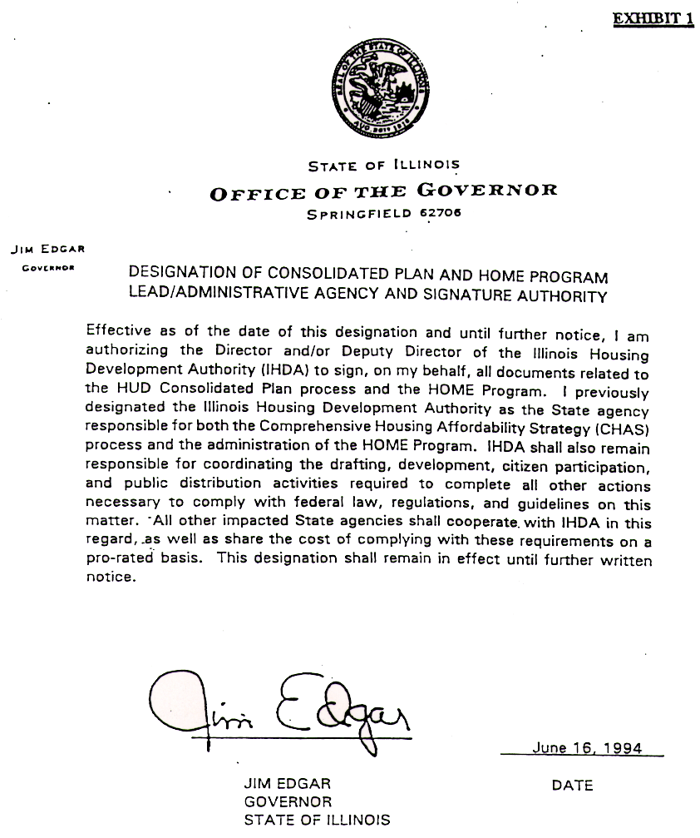

t:\ochs\2013certification of home consortium

